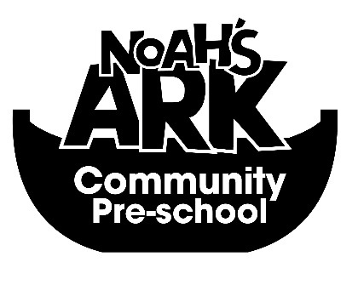

35a Bullying Policy-
NOAHS ARK COMMUNITY PRE-SCHOOL

Introduction
Although our Behaviour Policy is generally very effective, research shows that bullying exists in all Preschools. We aim to prevent it if possible, but have accepted procedures of dealing with it if and when it does arise.

Definitions of Bullying

Within our preschool we define bullying as:
- A person is bullied when s/he is exposed regularly and over time to negative actions on the part of one or more persons;
- Bullies are people who deliberately set out to intimidate, threaten and/or hurt others repeatedly. They can operate alone or as a group.
Children’s definition:
- A bully is someone who likes making others feel hurt, frightened or sad, and who keeps on doing it;
- Sometimes a bully gets a gang to help him or her, but not always;
- A bully might try to make you too scared to tell a grown up about what he or she does.
Please Note: Likes is used here to convey that there is intention. This definition could be used by a victim or a witness. This can include deliberate physical or verbal attacks, threatening behaviour or theft of another’s property.
Occasional fighting or falling out between friends or equals is not considered bulling

Aims
At Noah’s Ark pre-school we aim to:
- Make clear to everyone within the preschool community that no form of bullying is acceptable;
- Make everyone in the school community alert to the signs and evidence of bullying, and to have a responsibility to report it as an observer or victim;
- Ensure all reported incidents of bullying are followed up;
- Establish facts clearly, taking separate accounts from victims, bullies and witnesses;
- Offer comfort and support to victims;
- Confront bullies with the seriousness of the offence, but offer support and counselling to help them modify their behaviour and make amends;
- Seek parental and peer group support and co-operation at all times;
- Keep an incident log to record and monitor all incidents of bullying.

Procedures for Dealing with Bullying
In order to meet these aims and deal with bullying in an appropriate way we have agreed the following procedures:
- At the beginning of each academic year preschool Practionioners will clarify and agree Hall rules and consequences, based on the rights, responsibilities and rules specified in the school’s Behaviour Policy;
- Staff will work together to actively promote and “model” positive behaviour, attitudes and values;
- Pre-school will focus on positive behaviour and heightening awareness of rights and responsibilities, and review and reinforcement of rules, plus bullying and its consequences;
- Staff will talk with children about bullying and what they should do as an individual if they are bullied, or witness to or aware of any bullying;
- Everyone will be alert to signs of bullying and report it to staff, including the management team.
- If an incident of bullying is reported, both victim and the bully/ies, as well as any witnesses will be talked with individually by staff/management team.
- Facts will be established as clearly as possible and the bully made aware of the seriousness of his/her behaviour. The bully will be told the consequences of his/her actions, (See Consequences of Inappropriate Behaviour in the Behaviour Policy) supported in coming up with solutions, and offered support and counselling;
- The victim will be offered support, guidance and comfort;
- The Management team will be informed and the incident logged in the Incident Log Book;
- If the bullying continues, the bully’s parents (if the bully is a child) will be informed and talked with by the staff (key person) and/or someone from the management team. The bully will be talked with again and further consequences implemented. The bully’s behaviour will be monitored and a written log kept;
- If the bullying still continues the Manager will be involved and consider appropriate consequences and an action plan which could include:
  - Exclusion from the Preschool

Signs of Bullying
It is everyone’s responsibility to look out for signs of bullying. The following behaviours might be signs that a child is being bullied:
- Preschool refusal;
- Frequent illness;
- Not wishing to join in with group activities;
- Easily upset;
- Seems frightened of walking to/from nursery;
- Refuses to say what’s wrong;
- Comes home and cries
- Becomes withdrawn. Starts stammering;
- Attempts self-harm;
- Cries self to sleep;
- Has frequent nightmares;
- Has unexplained bruises/scratches/cuts;
- Has possessions go missing;
- Starts to wet themselves often;
- Gives an improbable excuse to explain any of the above.

Signed on behalf of the Pre-School:
Position: Manager
Date: 22/01/2019

