Covid Newsletter Summer 2020

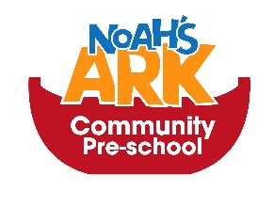
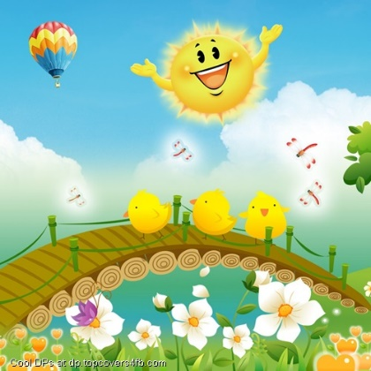
Dates to remember
End of Term 15th July 2020
Inset Days 16th – 20th July

Remember
If you or anybody in your family becomes unwell with a continuous cough, temperature or loss of taste and smell, then the whole family will need to isolate for 14 days in line with government guidance. If any child becomes unwell with the above symptoms, they will be sent home. Whilst the child is awaiting collection, they will be placed in isolation with a staff member wearing PPE away from others until they are picked up. It is vital we are able to get in touch with parents immediately; therefore, please ensure we have your most up to date contact details.
News
Thank you to all our parents for being patient and understanding throughout the Covid crisis so far. We reopened on the 15th June and have had all our places for this term filled almost immediately. The children have enjoyed returning and are enjoying the amazing summer we’re having playing outdoors. I know we are not doing the trips or the get together picnic and graduation at Hollow Ponds this year with parents and children, but we will do a picnic with children, weather allowing on the 15th July. We also hope to do a small graduation for those leaving us.
Please bear with us during this time as we will be changing routines and procedures depending on government guidelines and risk assessments.
We are currently in the process of completing transitions for children leaving us this year and moving on to other schools. If you have not yet informed us of the new school your child will be attending please email us by the end of this week so we can ensure they are all sent out by next week. Thanks.

We Will be preparing snacks and treats for children on the last day but no cooked food. There will also be end of year activities such as fun sports for the children and obstacle course.
#No nuts!
We will be asking for a small contribution from parents as unfortunately we cannot accept cooked foods from parents this year.

Reminders
If your child does not yet have indoor shoes/slippers, please can you provide some. Can we please have closed shoes for when the children go outdoors.
Please don’t forget to bring a change of clothes for your child every Monday for the whole week, more if they are potty training.
Please remember to apply sun protection cream to your child before you leave them at the pre-school and leave a named bottle of sun cream in their bags.
If you are bringing in food for snacks for your child, please remember not to bring anything with nuts in, thank you.
Please find attached the new term dates for next year for those children returning to Preschool.

Thank you from all the staff at Noah’s Ark Community Pre-School for all your support and understanding over this period.

Term dates 2020 - 2021

Autumn Term 2020
- Monday 7th September to Friday 18 December 2020
- Half Term: Monday 26 October to Friday 30 October 2020
- Christmas holiday: Monday 21December 2020 to Friday 1 January 2021

Spring Term 2021
- Monday 4 January 2021 to Thursday 1 April 2021
- Half Term: Monday 15 February to Friday 19 February 2021
- Easter Holiday Friday 2 April 2021 to Friday 16 April 2021

Summer Term 2020
- Monday 19 April 2021 to Thursday 22 July 2021
- Half Term: Tuesday 1 June to Friday 4 June 2021

Inset Days 2020
- Wednesday 2nd September to Friday 4th September

This calendar gives a total of 195 days. A maximum of 5 staff development (INSET) days will be deducted. The remainder of two days inset will be given during the year when training can be booked.
Please note these dates could be changed depending on government guidance during this Covid Pandemic.
Thank you for your support.

